**01. Convert the binary number 10111010 into its hexadecimal equivalent. Select the correct answer from the list below.**

* 85
* 90
* BA
* A1
* B3
* 1C

**02. Which of the following describe interframe spacing? (Choose two.)**

* the minimum interval, measured in bit-times, that any station must wait before sending another frame
* the maximum interval, measured in bit-times, that any station must wait before sending another frame
* the 96-bit payload padding inserted into a frame to achieve a legal frame size
* the 96-bit frame padding transmitted between frames to achieve proper synchronization
* the time allowed for slow stations to process a frame and prepare for the next frame
* the maximum interval within which a station must send another frame to avoid being considered unreachable

**03. When a collision occurs in a network using CSMA/CD, how do hosts with data to transmit respond after the backoff period has expired?**

* The hosts return to a listen-before-transmit mode.
* The hosts creating the collision have priority to send data.
* The hosts creating the collision retransmit the last 16 frames.
* The hosts extend their delay period to allow for rapid transmission.

**04. After an Ethernet collision, when the backoff algorithm is invoked, which device has priority to transmit data?**

* the device involved in the collision with the lowest MAC address
* the device involved in the collision with the lowest IP address
* any device in the collision domain whose backoff timer expires first
* those that began transmitting at the same time

**05. Which of the following is a drawback of the CSMA/CD access method?**

* Collisions can decrease network performance.
* It is more complex than non-deterministic protocols.
* Deterministic media access protocols slow network performance.
* CSMA/CD LAN technologies are only available at slower speeds than other LAN technologies.

**06. 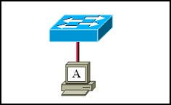Refer to the exhibit. The switch and workstation are administratively configured for full-duplex operation. Which statement accurately reflects the operation of this link?**

* No collisions will occur on this link.
* Only one of the devices can transmit at a time.
* The switch will have priority for transmitting data.
* The devices will default back to half duplex if excessive collisions occur.

**07. Why do hosts on an Ethernet segment that experience a collision use a random delay before attempting to transmit a frame?**

* A random delay is used to ensure a collision-free link.
* A random delay value for each device is assigned by the manufacturer.
* A standard delay value could not be agreed upon among networking device vendors.
* A random delay helps prevent the stations from experiencing another collision during the transmission.

**08. 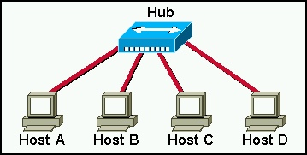In the graphic, Host A has reached 50% completion in sending a 1 KB Ethernet frame to Host D when Host B wishes to transmit its own frame to Host C. What must Host B do?**

* Host B can transmit immediately since it is connected on its own cable segment.
* Host B must wait to receive a CSMA transmission from the hub, to signal its turn.
* Host B must send a request signal to Host A by transmitting an interframe gap.
* Host B must wait until it is certain that Host A has completed sending its frame.

**09. Ethernet operates at which layers of the OSI model? (Choose two.)**

* Network layer
* Transport layer
* Physical layer
* Application layer
* Session layer
* Data-link layer

**10. What does the IEEE 802.2 standard represent in Ethernet technologies?**

* MAC sublayer
* Physical layer
* Logical Link Control sublayer
* Network layer

**11. Which statements correctly describe MAC addresses? (Choose three.)**

* dynamically assigned
* copied into RAM during system startup
* layer 3 address
* contains a 3 byte OUI
* 6 bytes long
* 32 bits long

**12. 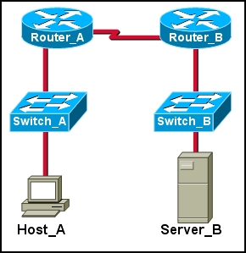Refer to the exhibit. Host_A is attempting to contact Server_B. Which statements correctly describe the addressing Host_A will generate in the process? (Choose two.)**

* A packet with the destination IP of Router_B.
* A frame with the destination MAC address of Switch_A.
* A packet with the destination IP of Router_A.
* A frame with the destination MAC address of Router_A.
* A packet with the destination IP of Server_B.
* A frame with the destination MAC address of Server_B.

**13. Host A has an IP address of 172.16.225.93, a mask of 255.255.248.0, and a default gateway of 172.16.224.1. Host A needs to send a packet to a new host whose IP is 172.16.231.78. Host A performs the ANDing operation on its address and subnet mask. What two things will occur? (Choose two.)**

* Host A will get a result of 172.16.224.0 from the AND process.
* Host A will send on to the media a broadcast frame that contains the packet.
* Host A will broadcast an ARP request for the MAC of the host 172.16.231.78.
* Host A will change the destination IP of the packet to 172.16.224.1 and forward the packet.
* Host A will encapsulate the packet in a frame with a destination MAC that is the MAC address associated with 172.16.224.1.

**14. Which two features make switches preferable to hubs in Ethernet-based networks? (Choose two.)**

* reduction in cross-talk
* minimizing of collisions
* support for UTP cabling
* division into broadcast domains
* increase in the throughput of communications

**15. Ethernet operates at which layer of the TCP/IP network model?**

* application
* physical
* transport
* internet
* data link
* network access

**16. What are three functions of the upper data link sublayer in the OSI model? (Choose three.)**

* recognizes streams of bits
* identifies the network layer protocol
* makes the connection with the upper layers
* identifies the source and destination applications
* insulates network layer protocols from changes in physical equipment
* determines the source of a transmission when multiple devices are transmitting

**17. What three primary functions does data link layer encapsulation provide? (Choose three.)**

* addressing
* error detection
* frame delimiting
* port identification
* path determination
* IP address resolution

**18. What are the two most commonly used media types in Ethernet networks today? (Choose two.)**

* coaxial thicknet
* copper UTP
* coaxial thinnet
* optical fiber
* shielded twisted pair

**19. 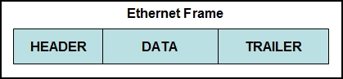Refer to the exhibit. Which option correctly identifies content that the frame data field may contain?**

* preamble and stop frame
* network layer packet
* physical addressing
* FCS and SoF

**20. What is the primary purpose of ARP?**

* translate URLs to IP addresses
* resolve IPv4 addresses to MAC addresses
* provide dynamic IP configuration to network devices
* convert internal private addresses to external public addresses